**Objective:**

The objective of this analysis was to explore key HR metrics, identify trends, and derive actionable insights to enhance workforce management, reduce attrition, and optimize HR programs.

**Dataset Description:**

The dataset comprises 15000 records, covering attributes such as satisfaction_level, last_evaluation, number_project, time_spend_company, Work_accident, left, promotion_last_5years, sales, and salary

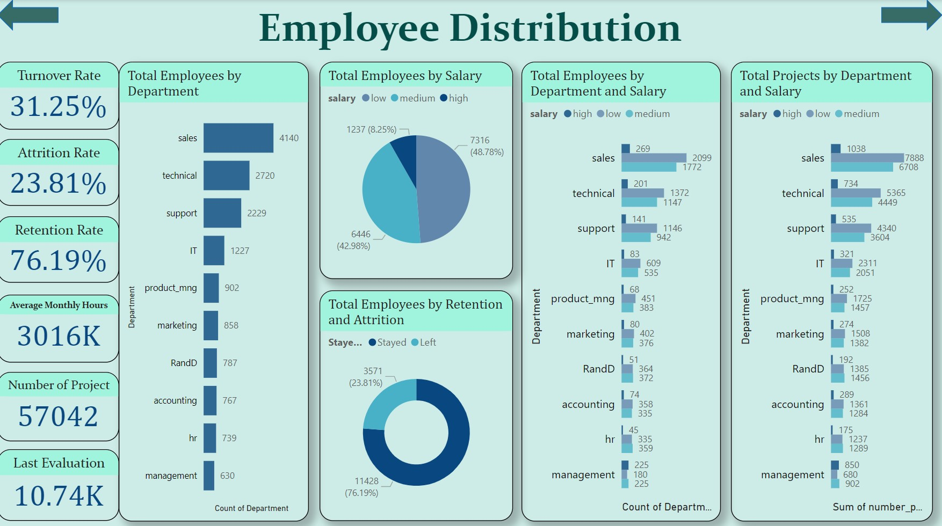

This **Employee Distribution Dashboard** provides a comprehensive view of employee metrics across departments, salaries, retention rates, and project allocations. Here's a detailed analysis of the key insights:

**1. Overview Metrics (Left Panel):**

* **Turnover Rate:**
  + 31.25% of employees have left the organization.
* **Attrition Rate:**
  + 23.81%, indicating a significant proportion of employees leaving voluntarily.
* **Retention Rate:**
  + 76.19% of employees have stayed in the company.
* **Average Monthly Hours:**
  + Total average monthly hours worked across all employees = **3016K** (3,016,000 hours).
* **Number of Projects:**
  + **57,042** projects have been handled by the organization.
* **Last Evaluation:**
  + Evaluation average score stands at **10.74K**, representing performance scores (aggregated).

**2. Total Employees by Department:**

This bar chart highlights the distribution of employees across departments:

* **Sales:** Largest workforce with **4,140 employees**.
* **Technical:** **2,720 employees**, the second-largest group.
* **Support:** **2,229 employees**.
* **Smallest departments:**
  + Management (630)
  + HR (739)
  + Accounting (767)

**3. Total Employees by Salary:**

The **salary distribution** is divided into **Low**, **Medium**, and **High** salary bands:

* **Low Salary:** **7316 employees** (48.78%).
* **Medium Salary:** **6446 employees** (42.98%).
* **High Salary:** **1237 employees** (8.25%).

**Observation:** A majority of employees fall into the low and medium salary categories, indicating a smaller proportion in higher pay bands.

**4. Total Employees by Department and Salary:**

This horizontal bar chart provides department-wise salary distribution:

* **Sales:**
  + High: **269**, Medium: **2099**, Low: **1772**.
* **Technical:**
  + High: **201**, Medium: **1372**, Low: **1147**.
* **Support:**
  + High: **141**, Medium: **1146**, Low: **942**.

**Key Trends:**

* Sales and Technical departments dominate all salary bands.
* **IT, Product Management, and HR** have the lowest representation in the **high salary** category.

**5. Total Employees by Retention and Attrition:**

* **Stayed:** **11,428 employees** (76.19%).
* **Left:** **3,571 employees** (23.81%).

**Observation:** A high retention rate of **76%** is a positive indicator, although the attrition rate (23%) remains notable.

**6. Total Projects by Department and Salary:**

This visualization shows the sum of projects handled across departments categorized by salary:

* **Sales:**
  + High: **1038**, Medium: **7888**, Low: **6708**.
* **Technical:**
  + High: **734**, Medium: **5365**, Low: **4449**.
* **Support:**
  + High: **535**, Medium: **4340**, Low: **3604**.

**Key Insights:**

* Sales and Technical departments lead project contributions.
* **Management** and **HR** departments handle fewer projects compared to others.

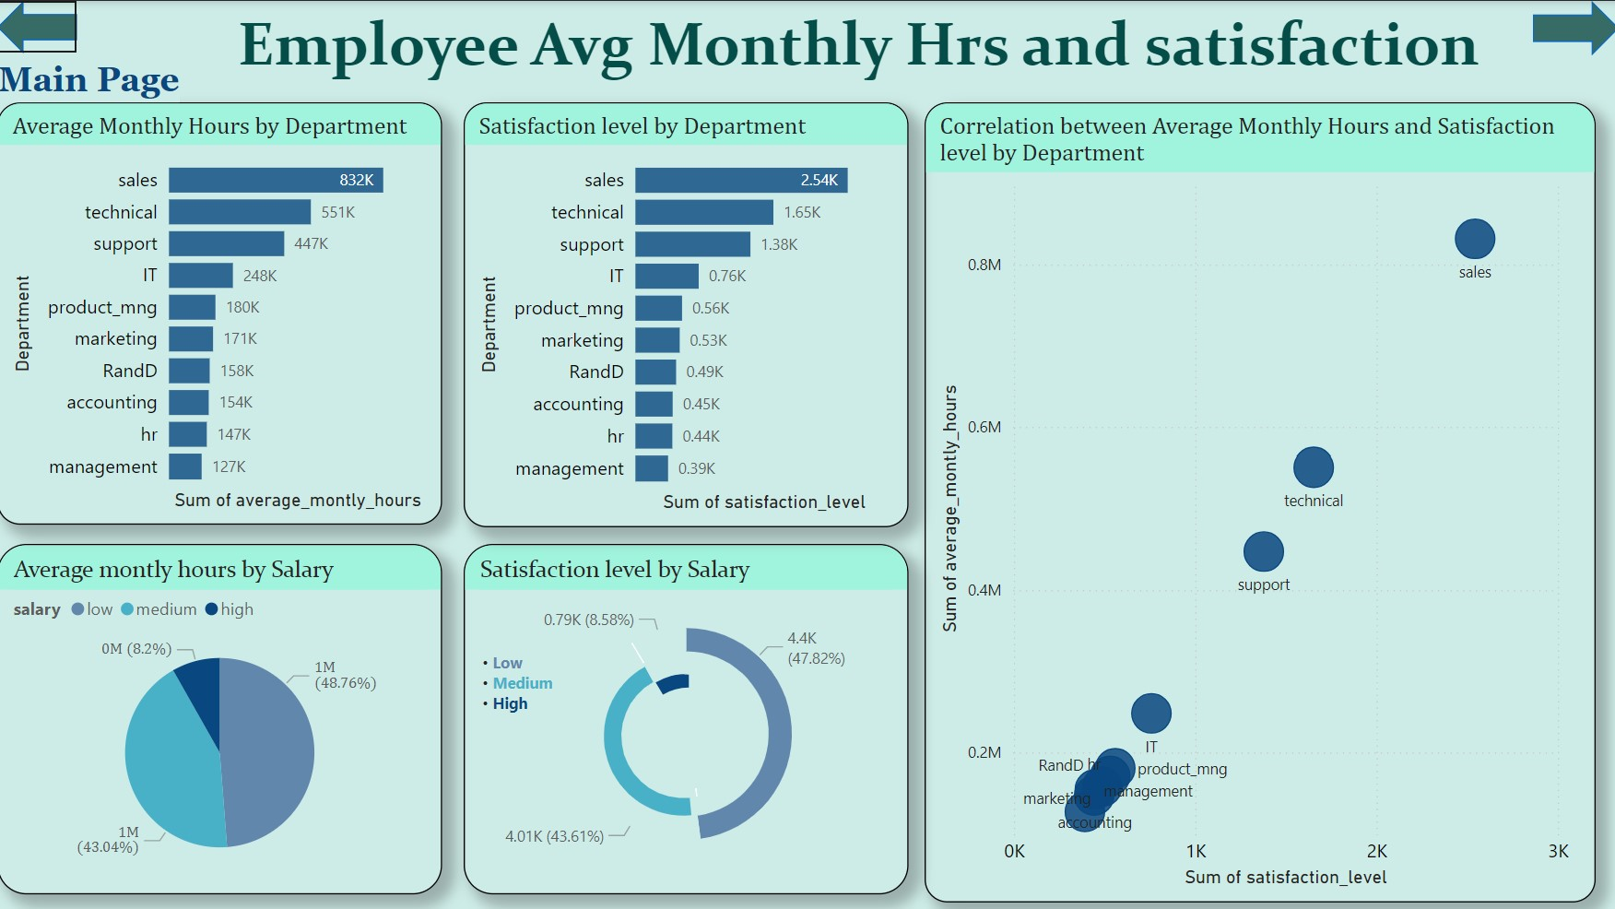

This **Employee Average Monthly Hours and Satisfaction Dashboard** analyzes key metrics related to employee workload, satisfaction, and correlations between the two. Here's a detailed breakdown:

**1. Average Monthly Hours by Department:**

This bar chart shows the **sum of average monthly hours** worked across departments:

* **Sales:** **832K** hours, the highest workload.
* **Technical:** **551K** hours.
* **Support:** **447K** hours.
* **IT, Product Management, and Marketing:** Lower workloads between 171K-248K hours.
* **Management:** **127K** hours, the lowest among departments.

**Key Insight:**  
Sales, Technical, and Support teams are the most burdened with working hours.

**2. Satisfaction Level by Department:**

The **sum of satisfaction levels** across departments is visualized here:

* **Sales:** **2.54K**, the highest satisfaction level.
* **Technical:** **1.65K**, ranking second.
* **Support:** **1.38K**.
* **IT:** **0.76K**, relatively low satisfaction.
* **Management:** **0.39K**, the lowest satisfaction level.

**Observation:**  
Sales and Technical teams show high satisfaction, likely due to higher recognition or engagement despite heavy workloads.

**3. Correlation Between Average Monthly Hours and Satisfaction:**

The scatter plot reveals the relationship between **average monthly hours** and **satisfaction levels** by department:

* **Sales:** High workload (832K hours) correlates with the highest satisfaction.
* **Technical and Support:** Moderate workloads align with moderate satisfaction.
* **Management, Accounting, and R&D:** Low workloads are associated with lower satisfaction.

**Key Insight:**  
There is no clear negative correlation between working hours and satisfaction. In fact, high workloads (Sales) are linked to higher satisfaction.

**4. Average Monthly Hours by Salary:**

The **salary-based workload distribution** is shown in a pie chart:

* **Low Salary:** **48.76%** contribute the highest hours.
* **Medium Salary:** **43.04%**.
* **High Salary:** Only **8.2%** of total hours.

**Observation:**  
The majority of working hours are logged by employees in **low and medium salary bands**, highlighting an imbalance.

**5. Satisfaction Level by Salary:**

The **satisfaction level by salary** is visualized as a circular bar:

* **Low Salary:** **43.61%** satisfaction.
* **Medium Salary:** **47.82%**, the highest satisfaction.
* **High Salary:** Only **8.58%**, despite fewer hours worked.

**Key Insight:**  
Medium-salary employees report the highest satisfaction, while high-salary employees' satisfaction is proportionally lower.

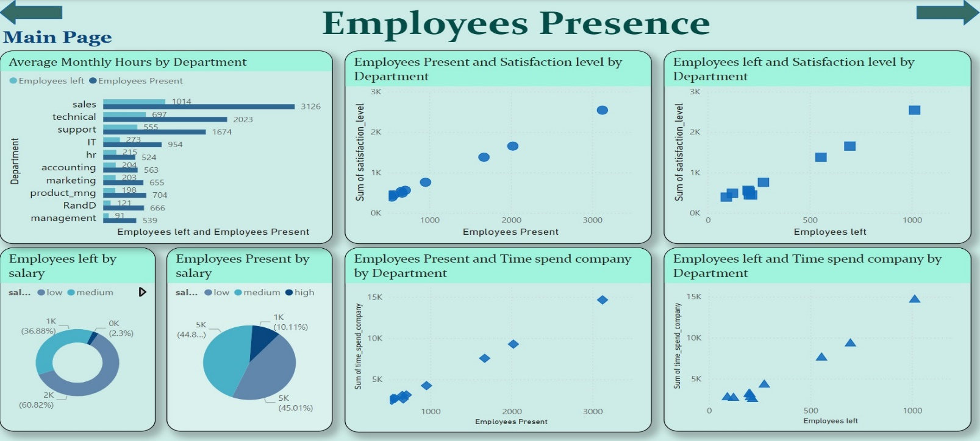

This **Employee Presence Dashboard** provides an analysis of employee presence, attrition, satisfaction, and time spent across various departments and salary levels. Here's a detailed breakdown:

**1. Average Monthly Hours by Department:**

* This **bar chart** compares employees **left** (blue) vs. **present** (gray) based on average monthly hours:
  + **Sales:** 1014 (left), **3126 (present)** — **highest retention** despite high workload.
  + **Technical:** 697 (left), **2023 (present)** — relatively high retention.
  + **Support:** 555 (left), **1674 (present)** — significant attrition but still a stable workforce.
  + **Management:** **121 (left), 539 (present)** — lowest workforce among departments.

**Key Insight:**  
Sales, Technical, and Support departments have the largest workforce but also experience considerable employee attrition.

**2. Employees Present and Satisfaction Level by Department:**

* This **scatter plot** correlates the **number of employees present** with their overall **satisfaction level**:
  + Departments with more employees (e.g., **Sales** and **Technical**) report **higher satisfaction levels** (closer to 2K–3K).
  + Smaller departments like **R&D** and **HR** have lower satisfaction.

**Observation:**  
Higher presence correlates positively with satisfaction, especially in larger departments.

**3. Employees Left and Satisfaction Level by Department:**

* This scatter plot shows the relationship between **employees who left** and their **satisfaction levels**:
  + Departments with higher attrition (e.g., **Sales** and **Technical**) show relatively higher satisfaction levels (~2K).
  + Smaller departments like **HR** and **R&D** with fewer employees left show lower satisfaction.

**Key Insight:**  
While larger departments lose more employees in numbers, their satisfaction levels remain high, indicating the **attrition may not necessarily stem from dissatisfaction**.

**4. Employees Left by Salary:**

* This **donut chart** illustrates attrition based on salary bands:
  + **Low Salary:** **60.82%** — the majority of employees who left.
  + **Medium Salary:** **36.88%**.
  + **High Salary:** **2.3%**, very minimal attrition.

**Observation:**  
Attrition is concentrated among low and medium-salary employees.

**5. Employees Present by Salary:**

* This **pie chart** shows the distribution of employees present across salary bands:
  + **Low Salary:** **44.8%** of the workforce.
  + **Medium Salary:** **45.01%**, the highest.
  + **High Salary:** **10.11%**, relatively fewer employees.

**Insight:**  
The workforce is evenly split between low and medium salaries, with very few employees in the high-salary band.

**6. Employees Present and Time Spent by Department:**

* This scatter plot maps **employees present** to the **sum of time spent in the company**:
  + Departments like **Sales** and **Technical** have **high time spent**, correlating with a larger workforce.
  + Smaller departments show significantly less time spent.

**Observation:**  
Larger departments retain employees longer, reflecting a more established workforce.

**7. Employees Left and Time Spent by Department:**

* This scatter plot highlights the relationship between **employees who left** and their **time spent in the company**:
  + Departments like **Sales** and **Technical** have higher attrition among employees who spent significant time (~10K–15K hours).
  + Smaller departments (e.g., R&D, Management) have lower attrition and time spent.

**Insight:**  
Employees leaving larger departments tend to have higher tenure, indicating potential burnout or career progression issues.

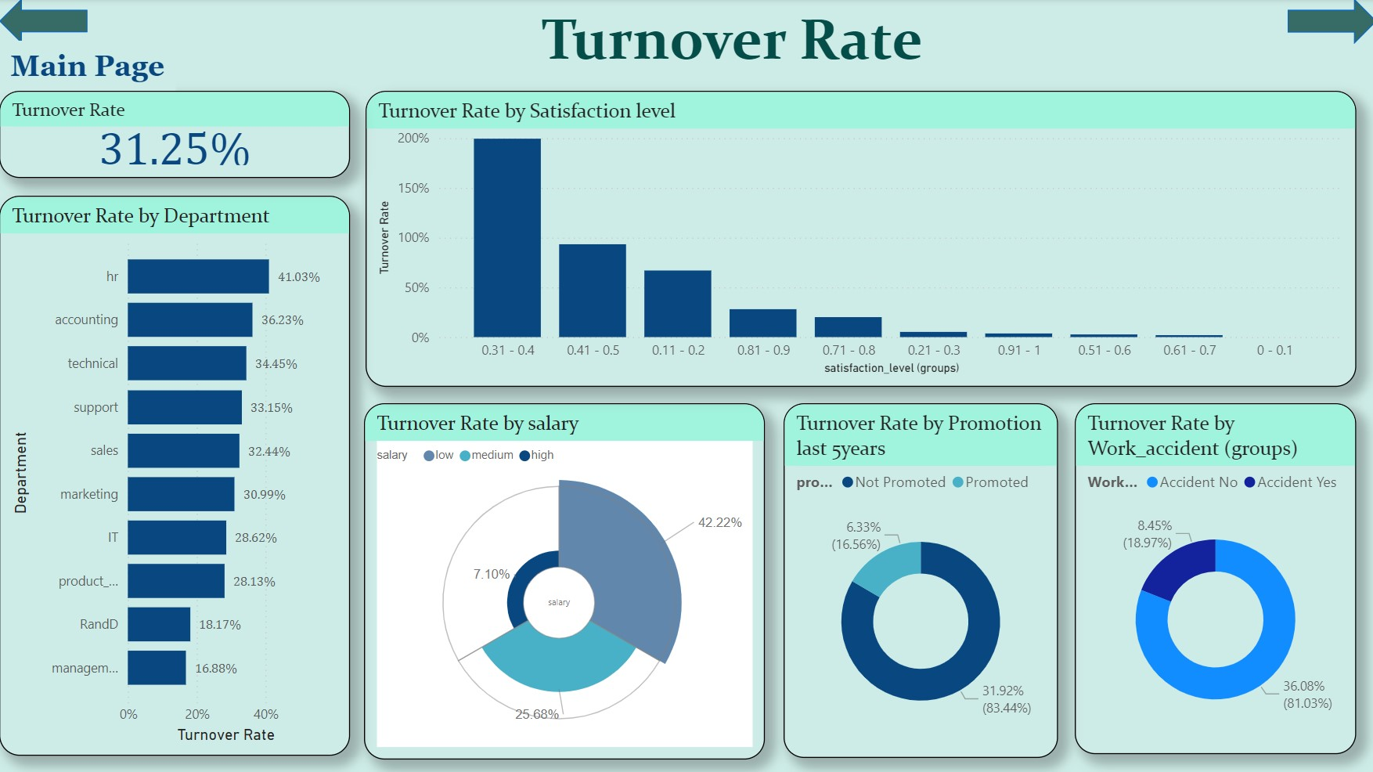

This dashboard provides an overview of employee turnover rates with key metrics and visualizations that break down the turnover based on various factors. Here's a detailed analysis:

**1. Overall Turnover Rate**

* **Turnover Rate**: **31.25%**
  + This represents the proportion of employees who left the organization within a certain period.

**2. Turnover Rate by Department**

The turnover rates for various departments are as follows:

* **HR**: 41.03% (highest turnover)
* **Accounting**: 36.23%
* **Technical**: 34.45%
* **Support**: 33.15%
* **Sales**: 32.44%
* **Marketing**: 30.99%
* **IT**: 28.62%
* **Product**: 28.13%
* **R&D**: 18.17%
* **Management**: 16.88% (lowest turnover)

**Observation**:

* HR and Accounting departments have significantly higher turnover rates compared to Management and R&D.
* This may indicate issues specific to HR/accounting roles, such as job satisfaction, workload, or compensation.

**3. Turnover Rate by Satisfaction Level**

* Employees with lower satisfaction levels show higher turnover.
  + **0.31 - 0.4** range: **200%+ turnover** (extremely high).
  + As satisfaction levels increase, the turnover rate decreases significantly.
  + Very low turnover occurs for satisfaction levels **above 0.7**.

**Insight**:

* Employee satisfaction is a critical factor influencing turnover. Targeted efforts to increase satisfaction can reduce turnover.

**4. Turnover Rate by Salary**

* **Low salary**: 42.22% (highest turnover)
* **Medium salary**: 25.68%
* **High salary**: 7.10% (lowest turnover)

**Observation**:

* Higher turnover is associated with lower salaries, suggesting compensation may play a major role in turnover rates.

**5. Turnover Rate by Promotion (last 5 years)**

* **Not Promoted**: **31.92% turnover** (83.44%)
* **Promoted**: **6.33% turnover** (16.56%)

**Insight**:

* Employees who were not promoted in the last five years show significantly higher turnover, indicating career progression plays a vital role in retention.

**6. Turnover Rate by Work Accidents**

* **No Accident**: 36.08% (81.03%)
* **Accident Yes**: 8.45% (18.97%)

**Observation**:

* Employees involved in work accidents contribute to 18.97% of the turnover.
* While the overall turnover rate is higher for employees without accidents, work safety could still be influencing employee retention indirectly.

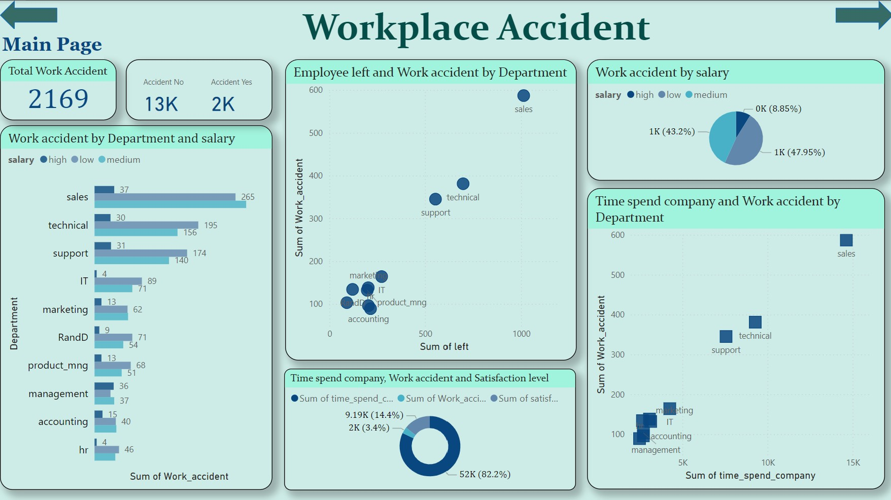

This dashboard focuses on **Workplace Accidents** with key insights related to departments, salaries, and time spent in the company. Below is the detailed analysis:

**1. Total Workplace Accidents**

* **Total Work Accidents**: **2,169**
* Breakdown:
  + **Accident No**: **13K**
  + **Accident Yes**: **2K**

**Insight**: A small proportion (approximately **13%**) of employees reported workplace accidents.

**2. Work Accident by Department and Salary**

This bar chart highlights workplace accidents across departments, categorized by salary levels:

* **Sales**:
  + **265 (low salary)**, **37 (medium salary)**
* **Technical**:
  + **195 (low salary)**, **30 (medium salary)**
* **Support**:
  + **174 (low salary)**, **31 (medium salary)**
* **IT, Marketing, RandD, and others**:
  + Lower numbers compared to Sales, Technical, and Support.

**Observation**:

* **Sales**, **Technical**, and **Support** departments have the highest number of workplace accidents.
* Most accidents occur among **low-salary** employees, which indicates that lower compensation might be linked to higher accident rates, possibly due to job nature or lack of resources.

**3. Employee Left and Work Accident by Department**

* The scatter plot shows the **relationship between employees leaving** and **workplace accidents** by department:
  + **Sales**: Highest accidents and employee turnover.
  + **Technical**: Moderate accidents and employee exits.
  + **Support**: High accidents but fewer employee exits compared to Sales.

**Insight**:

* Departments with higher workplace accidents (Sales, Technical, and Support) also experience significant turnover. Accidents might contribute to employees leaving.

**4. Work Accident by Salary**

This pie chart categorizes accidents by salary levels:

* **Low Salary**: 47.95% (1K accidents)
* **Medium Salary**: 43.2% (1K accidents)
* **High Salary**: 8.85%

**Observation**:

* Employees with **low and medium salaries** account for nearly 90% of workplace accidents.
* High-salary employees report significantly fewer accidents.

**Insight**:

* Roles with lower compensation are more prone to accidents, possibly due to physical job demands or lack of safety resources.

**5. Time Spent in Company and Work Accident by Department**

The scatter plot shows workplace accidents vs. time spent in the company:

* **Sales**: Highest accidents despite employees spending significant time.
* **Technical and Support**: Moderate accidents with longer time spent.
* Other departments (e.g., IT, Marketing) report fewer accidents with shorter company tenures.

**Observation**:

* Departments like **Sales** and **Support** experience higher accidents over time, indicating persistent issues despite tenure.

**6. Time Spent in Company, Work Accidents, and Satisfaction**

The donut chart summarizes:

* **Sum of Time Spent in Company**: 82.2% (52K)
* **Sum of Work Accidents**: 3.4% (2K)
* **Sum of Satisfaction**: 14.4% (9.19K)

**Insight**:

* Despite considerable time spent in the company, work accidents remain a concern, potentially contributing to lower satisfaction.

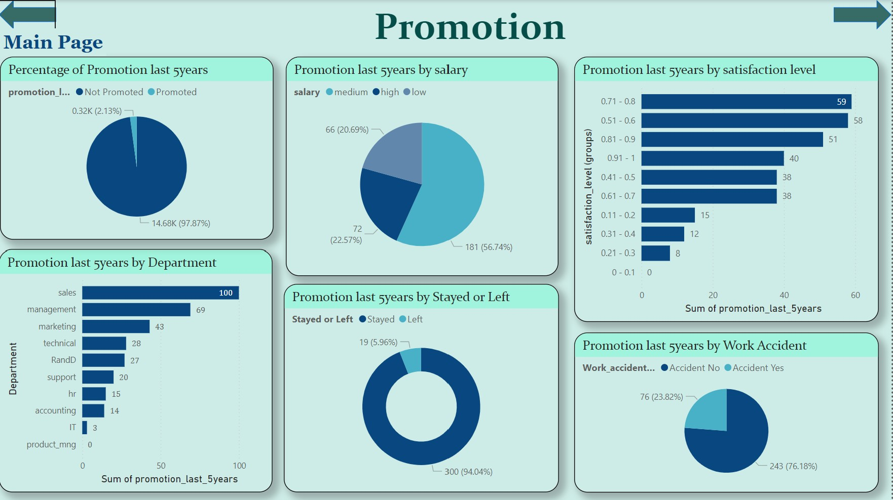

This dashboard focuses on **Promotions** in the last 5 years, broken down by various factors such as salary, satisfaction, departments, employee retention, and workplace accidents. Below is the detailed analysis:

**1. Percentage of Promotions in the Last 5 Years**

* **Promoted**: **2.13%** (0.32K employees)
* **Not Promoted**: **97.87%** (14.68K employees)

**Insight**:

* Promotions are extremely rare, with only a small fraction (**2.13%**) of employees receiving a promotion in the last 5 years. This could contribute to dissatisfaction or turnover.

**2. Promotion by Salary**

* **Low Salary**: **181 (56.74%)**
* **Medium Salary**: **72 (22.57%)**
* **High Salary**: **66 (20.69%)**

**Observation**:

* Employees with **low salaries** are promoted the most, followed by those with medium and high salaries.
* This might indicate an effort to elevate lower-paid employees or a lack of higher-level promotion opportunities.

**3. Promotion by Satisfaction Level**

* Promotions are more frequent among employees with higher satisfaction levels:
  + **0.71 - 0.8**: **59 promotions**
  + **0.51 - 0.6**: **58 promotions**
  + **0.81 - 0.9**: **51 promotions**
* Employees with **lower satisfaction levels** (e.g., **0.1 - 0.2** and below) rarely receive promotions.

**Insight**:

* Promotions are positively correlated with satisfaction. Employees with higher satisfaction levels are more likely to be promoted, which could also be a driver of that satisfaction.

**4. Promotion by Department**

* Departments with the most promotions:
  + **Sales**: **100** promotions (highest)
  + **Management**: **69** promotions
  + **Marketing**: **43** promotions
* Departments with the least promotions:
  + **IT**: **3** promotions
  + **Product Management**: **0** promotions

**Observation**:

* Sales and Management departments receive the most promotions, potentially due to performance-based incentives or structured career growth.
* IT and Product Management departments are notably under-promoted, which may indicate stagnation or fewer growth opportunities.

**5. Promotion by Employee Retention (Stayed vs. Left)**

* **Stayed**: **94.04%** (300 promotions)
* **Left**: **5.96%** (19 promotions)

**Insight**:

* Promotions overwhelmingly favor employees who remain with the company.
* Only a small portion of promotions occur among employees who later leave.

**Key takeaway**:

* Promotions may incentivize retention, but employees who don’t receive promotions may eventually leave.

**6. Promotion by Workplace Accident**

* **No Workplace Accident**: **243 (76.18%)** promotions
* **Had Workplace Accident**: **76 (23.82%)** promotions

**Observation**:

* Employees who **did not experience workplace accidents** were promoted far more frequently.
* This suggests that workplace safety or health may influence an employee’s likelihood of being promoted.

**Final Conclusion and Strategic Recommendations**

The analysis provides a comprehensive overview of the organization's workforce challenges, including turnover, satisfaction, compensation, workload, promotion rates, and workplace safety. The following is a consolidated conclusion with prioritized action items:

**1. High Turnover and Attrition**

**Observation:**

* The overall turnover rate stands at **31.25%**, with HR (**41.03%**) and Accounting (**36.23%**) showing the highest attrition.
* Low-salary employees experience **42.22% turnover**, compared to **7.10%** in the high-salary group.
* Employees **not promoted** in the last 5 years report significantly higher turnover (**31.92%**).

**Recommendations:**

* **Focus on Career Development:** Implement structured promotion frameworks and upskilling programs to reduce attrition.
* **Compensation Reviews:** Prioritize salary adjustments for low-salary employees to enhance retention.
* **Targeted Retention in HR and Accounting:** Conduct employee engagement surveys to address specific dissatisfaction factors in these departments.

**2. Salary Imbalance and Low-Salary Overburden**

**Observation:**

* **48.78%** of employees earn low salaries, yet they contribute disproportionately to total working hours and face **lower satisfaction**.
* High-salary employees report **lower workloads but also lower satisfaction**, signaling a lack of challenging work or engagement.

**Recommendations:**

* **Restructure Salaries:** Address disparities by revisiting salary structures to reward effort and align compensation with performance.
* **Growth Opportunities for Low-Salary Employees:** Provide training, incentives, and clear career paths to improve satisfaction.
* **Reengage High-Salary Employees:** Offer challenging projects, leadership roles, or opportunities to mentor others.

**3. Departmental Imbalance in Workload and Satisfaction**

**Observation:**

* **Sales** and **Technical** departments dominate workforce presence, report high satisfaction, but also face high turnover and workload.
* Smaller departments like **HR**, **R&D**, and **Management** report **low satisfaction** despite fewer projects.

**Recommendations:**

* **Optimize Workload Distribution:** Ensure fair workload allocation to reduce burnout in overburdened departments like Sales and Technical.
* **Engagement Programs for Smaller Departments:** Implement initiatives to improve job fulfillment and role clarity for HR, R&D, and Management teams.
* **Benchmark Best Practices:** Use successful strategies from Sales and Technical teams to replicate satisfaction in underperforming departments.

**4. Workplace Safety and Accidents**

**Observation:**

* **Work accidents** impact retention, satisfaction, and promotion opportunities, particularly in Sales, Support, and Technical departments.
* Employees involved in accidents face lower promotion rates and increased turnover.

**Recommendations:**

* **Proactive Safety Measures:** Conduct safety audits and training programs in high-risk departments.
* **Ensure Fairness in Promotions:** Implement policies to ensure workplace accidents do not hinder career growth.
* **Improve Retention:** Link safety improvements with retention strategies to build trust and reduce exits.

**5. Promotion and Career Progression**

**Observation:**

* Only **2.13%** of employees were promoted, which is a major factor behind high turnover and dissatisfaction.
* Under-promoted departments like **IT** and **Product Management** lack growth opportunities.

**Recommendations:**

* **Develop Clear Career Paths:** Establish transparent promotion criteria and ensure equal growth opportunities across all departments.
* **Recognize High Potential:** Identify and promote high-performing employees to boost morale and retain top talent.
* **Mentorship Programs:** Pair experienced employees with newer ones to improve engagement and career progression.

**6. Workforce Stability and Retention Priorities**

**Key Insights:**

* Satisfaction levels strongly correlate with retention, especially in departments with heavy workloads.
* Medium-salary employees have the **highest satisfaction and retention**, representing a sweet spot for workforce stability.

**Recommendations:**

* **Retain Medium-Salary Workforce:** Offer targeted incentives, recognition programs, and growth opportunities to maintain stability.
* **Improve Job Satisfaction:** Use satisfaction drivers (e.g., incentives, meaningful work) from high-performing teams like Sales and Technical to uplift morale in other areas.

**Final Strategic Focus Areas**

To improve workforce stability, satisfaction, and retention, the organization must prioritize the following areas:

1. **Reduce Turnover** by addressing compensation issues and providing structured career growth opportunities.
2. **Balance Workload** across departments and focus on fair workload distribution for overburdened employees.
3. **Promote Workplace Safety** through proactive interventions in high-risk departments like Sales, Support, and Technical.
4. **Enhance Promotions and Engagement** to improve morale and satisfaction, especially in underperforming departments.
5. **Revisit Salary Structures** to retain low-salary employees and reengage high-salary employees through meaningful work.

By implementing these targeted strategies, the organization can achieve significant improvements in employee retention, satisfaction, and overall productivity.

Bottom of Form